­



**USMAN INSTITUTE OF TECHNOLOGY**

Affiliated with NED University of Engineering & Technology, Karachi

**Department of Computer Science**

B.S. Computer Science / Software Engineering

FINAL YEAR PROJECT REPORT

**Batch-2018**

**PROJECT NAME**

**By**

|  |  |
| --- | --- |
| Muhammad Farooq | 18B-021-CS |
| Abdur Rafay | 18B-088-CS |
| Ghayyas Ahmed | 18B-124-CS |
| Muhammad Jamal | 17B-030-CS |
|  |  |

**Supervised by**

Engr. Rabia Zuberi

*ST-13, Block 7, Gulshan-e-Iqbal, Abul Hasan Isphahani Road, Opposite Safari Park, P.O. Box 75300,*

*Karachi, Pakistan. Phone: 34978274-5; 34994305; 34982476;* [*http://www.uit.edu*](http://www.uit.edu/)

Declaration

I hereby declare that this project report is based on my original work except for citations and quotations which have been duly acknowledged. I also declare that it has not been previously and concurrently submitted for any other degree or award at USMAN INSTITUTE OF TECHNOLOGY or other institutions.

|  |
| --- |
| Muhammad Farooq (18B-021-CS): |
| Signature: _______________________________ |
| Abdur Rafay (18B-088-CS): |
| Signature: _______________________________ |
| Ghayyas Ahmed (18B-124-CS): |
| Signature: _______________________________ |
| Muhammad Jamal (17B-030-CS): |
| Signature: _______________________________ |
|  |
| Date: _______________________ |

**Acknowledgments**

This page should consist of the acknowledgements to the people, companies and institutions that have been helpful to the author in compiling the reports. It is normal practice to thank the Head of Institute for the use of facilities with which the project was carried out, the head of department, the supervisor for his/her suggestions and guidance and any other member of the academic and technical support staff who have made a significant contribution to the success of the project, and finally your family member (that is optional).

**Abstract**

The abstract is a brief summary of your research. Typically, an abstract should be one page and/or less than 350 words. Your abstract should consist of concise and precise to inform the reader of the content of the report, what the project was about, the main aim of the project, how the work was undertaken and major conclusions drawn from the work performed. It is important not to confuse an abstract with introduction. The first sentence should give the subject of the report and the last sentence should state the primary conclusion of the report. The abstract should be written in the present tense. It should not include illustrative material such as formulas, diagrams, and charts. The abstract page numbered ii. It should conclude with a short entry ‘Keywords’, Nominating several keywords by which a computerized library would find the project.

**Table of contents**

Contents

**Acknowledgments** **Error! Bookmark not defined.**

**Abstract 4**

**Table of contents 5**

**List of tables 7**

**List of figures 9**

**List of symbols and Units 10**

**1.** 10

**2.** 11

**3.** 20

**4.** 22

**5.** 30

**6.** 32

**7.** 34

**8.** 36

**9.** **Error! Bookmark not defined.**

**10.** 38

**11.** 40

**12.** 42

**13.** 44

**14.** 48

14.1 49

14.2 49

14.3 50

14.4 50

14.5 50

14.6 51

14.7 51

14.8 51

14.9 51

14.10 51

*14.10.1* 52

*14.10.2* 52

*14.10.3* 52

*14.10.4* 52

*14.10.5* 53

*14.10.6* 53

*14.10.7* 53

*14.10.8* 54

*14.10.9* 54

*14.10.10* 54

*14.10.11* 54

*14.10.12* 55

*14.10.13* 55

*14.10.14* 55

*14.10.15* 55

The table of the contents is on a separate page and is numbered iii. The table of contents lists the sections of the report, a list of figures and a list of tables along with the page on which they begin. It is to be generated by MS word -> references -> table of contents, similarly list of tables and list of figures.

**List of tables**

**List of figures**

**List of symbols and Units**

A list of symbols and units should be included to assist the reader. This should include any Greek letters or other mathematical symbols together with the quantities to which they refer, and their appropriate units. Preferred 2-3 pages of UML notations used in the project.

# Introduction

When working on a global platform. There is always a need for a management system that automates your work and allows you to control, manage and monitor various aspects of your organization. There is no proper system to check or track assets that are being utilized in your organization or are in use of particular labor. Similarly, labor tracking is also hard to track. It would be better if the system is automated and live tracking is enabled for both functions. These services include indoor navigation for people, machinery inside organizations or educational institutions, asset tracking, location of patients inside a hospital. These types of services are also becoming a need of gigantic logistics or warehouse-based companies where there is a need of parcels or vehicle tracking.

Generating maintenance reports is also a challenging task if there is no proper monitoring on time. So, to cater to this problem, we've brought up a solution in which smart tags will use which will be attached to the asset or labor which will be providing real-time tracking of that particular asset or labor through routers and that router will be providing the data to the systems where the system will be providing the current location of that particular asset or labor.

# Background and Literature Review

## Similar Applications:

There are many Indoor positioning applications which utilize networking devices known as smart tags which provide data of an asset and labor for tracking. Some of the commercial based applications are:

### EZOfficeInventory:

EZOfficeInventory is an asset tracking software which uses RFID based smart tags to keep track of assets.

EZOfficeInventory offers the following services:

1. Asset Management
   * RFID management
   * Mobile Apps
   * GPS location
   * History locations
   * Excel import and export
   * Asset stock and inventory module
   * Audits
   * Check in and check outs
2. User Management
   * Custom Roles
   * Access control
   * Employee ID scan
   * Login with Google/Outlook
3. Maintenance Management
   * Service history
   * Maintenance alerts
   * Work order management
   * Service vendor management
   * Service tickets
4. Reports and Notifications
   * Custom Alerts
   * Custom Reports
   * Data backups
   * Customized views
   * Scheduled Reports

Costs for this software are around $35-50 for 100-200 assets tracking.

### Semtech Asset Tracking kit:

Semtech LoRa based asset tracking kit is a kit produced by Semtech company. It provides the transmitter and smart devices for tracking which can be easily setup on an asset and the asset is ready to go for tracking. All of the settings and configurations have been already done by Semtech. The client just has to provide the internet to the devices and setup the trackers on the desired assets, after the configuration of the hardware, the client has to setup its account in the web portal and then they can track the devices, view their position on a map.

An advantage of Semtech web portal is that it is based on cloud so the users can operate the application from anywhere if they are online. This asset tracking system provided by Semtech costs between $1000-1500.

### UBEAC:

uBeac is a IOT platform for digital transformation of data, integration and data visualization. uBeac allows the users to connect, execute and visualize real time data. Enterprises can utilize uBeac’s platform for indoor positioning, asset tracking and data visualization.

The process of setting up the network and software is simple, they just have to setup the internet, devices and transmitters and configure them in uBeac’s portal and the devices are ready for tracking. Users can log in to the web portal and can control their devices and get analytics of devices from there.

## Algorithms from Research Papers:

Location detection can be achieved using different techniques and algorithms. The data obtained from these algorithms are in the form of signal strength or range. The data extracted from these algorithms is used to determine position of an object.

### Triangulation:

Triangulation is one of the most used algorithms for triangulation. It uses geometric properties of triangles to obtain the distance or orientation of an object. It is possible in two ways: Lateration or angulation. The most common techniques for triangulation are: Time of arrival (TOA) and Time of difference (TDOA), Angle of arrival (AOA). Received signal strength (RSS) and return of flight (RTOF) can also be used sometimes in place of others. One factor that should be taken care of in these triangulation techniques is to line of sight (LOS) between transmitters and receivers. If LOS is not configured than accuracy of signal scatter, signal attenuation and multipath can be greatly impacted [1].

#### Lateration

TOA utilizes time that a signal takes to travel from a transmitter to a receiver, to calculate the distance between the two [2]. After obtaining the time, the distance is calculated using a simple linear motion equation [1]:

Where is the speed of light.

In 2D spaces this leads to the following circle equation [1].

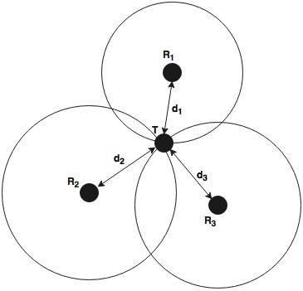Where are coordinates of a known reference point and are coordinates of a target.

Figure TOA measurements

If measurements from several devices are obtained that we can calculate the position of a target. Let’s suppose we have a target T and three reference points Ri as shown in fig. 1. If 2D coordinates of each Ri are known and distance between T and each of Ri is found, the 2D position of the target T can be calculated. For 2D positioning, minimum three reference points are required. If TOA is used then the internal time of each device must be in sync with other devices. TDOA is similar to TOA, as both use the time a signal takes to travel a distance between a transmitter and receiver [1].

#### Angulation:

Angulation of arrival algorithm some time called the direction of arrival (DOA) determines the target location by calculating the intersection of angles at which the signals arrive at receiving sensors. The distance between the target and references points can be calculated when the intersection is estimated. Only two angles are need to determine a 2D location [1].

### Fingerprinting:

Fingerprinting also known as Radio Fingerprinting is one of the most famous technologies for indoor positioning. Location fingerprinting are methods the match the *fingerprint* of some characteristic of a signal that is bound to a location [3]. It works on analysis of the scenario where a mapped area is analyzed and signal data in different locations are collected and stored to a database. If a target requests position data, signal data of the target’s position are compared to the database and the record which matches it the most is returned which is the estimated position. During the analysis, Received signal strength (RSS) is obtained during the analysis of scenario.

There are two stages for fingerprinting offline stage and online stage. In online stage, a location positioning algorithm uses the current estimated signal strengths and previously collected information to determine an estimated location. The main limitations of fingerprinting techniques is that the received signal strength could be disrupted by reflection, scattering and diffraction in indoor environments [3].

Algorithms for obtaining indoor positions using pattern recognition technique (fingerprinting) are of many types such as k-nearest neighbors, support vector machine, neural networks, smallest M-vertex polygon and probabilistic methods.

#### *kNN*:

The *k*NN averaging utilizes received signal strength RSS to find the *k* closest matches of known locations in signal space from the already built database according the rule of root mean square error. An estimated weighted *k*NN or unweighted *k*NN is determined by estimating these *k* location items with or without adopting the distances in signal space as weights [3].

Here *k* is an argument for better performance.

#### Support Vector Machines:

Support vector machine SVM is a novel and favorable technique for data classification and regression. It is known to be very well performing in applications of regression and classification. The theory of SVM is found in [4] and [5].

Support vector classification of multiple classes and support vector regression (SVR) have been found to be successful in fingerprinting.

#### Neural Networks:

The RSS and the respective location data are acquired as the inputs for the training purpose. Valid weights are found after the training of neural networks. Commonly, a multi-layer perceptron (MLP) network with one hidden layer is used for postioning system that is based on neural networks.

As it happens in neural networks, the weights are updated whenever bias is found so in positioning system whenever the product of offline RSS and trained input weight matrix is found to be bias then the weights will be updated. This result goes into the transfer function of the hidden layer neuron and the output is multiplied by the weight matrix of hidden layer and added to its weight matrix if bias is found. The output of the system is a 2D or 3D vector which is in fact a 2D or 3D location [3].

#### Smallest M-vertex Polygon (SMP):

SMP searches for device locations on each signal transmitter separately with the help of online RSS values. M-vertex polygons are configured by choosing minimum one device from each transmitter, here M is the total no. of transmitters. The location is determined by averaging the vertexes of the smallest polygon [3]. MultiLoc used SMP for localization [6].

#### Probabilistic Methods:

This method classifies positioning as a classification problem. If there are *n* location candidates *L1, L2, L3, …..., Ln,* and *s* is the observed signal strength vector during the online stage then the following rule is obtained:

Choose *L­­i­* if ,

Here, identifies the probability that the mobile candidate’s is , given that the RSS Is *s*. Using Bayes’ theorem, and assuming that for we have the following decision rule:

Choose *L­­i­* if ,

It is based on the probability that is the probability that the signal vector is received, given that the mobile node is located in location . Another approach for calculating the possibility is kernel approach as discussed in [7].

The Bayesian-network-based/tracking method was proposed because probabilistic methods for location sensitive application in wireless networks may become problematic in important issues like accuracy, active learning, error calculation and tracking with history [8].

### Proximity:

Proximity Algorithms provides the location based on comparisons. It works by deploying a grid of transmitters, when a mobile device is detected by a single transmitter, it is considered that it is in the location near to that respected transmitter. If the mobile device is in the range of more than one transmitter, than its location is based on the nearest transmitter.

This method is relatively simple to implement. It can be deployed on different type of physical devices. Asset tracking systems that are dependent on Infrared radiation (IR) and radio frequency identification (RFID) are often based on this method. Another method for device ident cation is using the cell of origin (COO) method. This method determines the location of the device by determining the cell to which the device is connected. It is already in use nowadays [3].

### Signal Propagation Modeling:

Signal propagation modeling, also called radio propagation modeling, is an alternative method to fingerprinting. In these algorithm, the user’s location is calculated by matching the signal strength acquired from real time data with the theoretically calculated signal strengths.

Most common models for signal propagation modeling are Ricean and Rayleig fading models.

### Weighted K-Nearest Neighbors Algorithm:

The weighted K-nearest neighbor (WKNN) algorithm is the most commonly used algorithm for indoor localization. WKNN algorithms adobe received signal strength (RSS) spatial distance (Manhattan or Euclidean distance) to select reference device (RDs) for position determination.

Algorithms such as KNN and WKNN adopt spatial distance (SD) of RSS between RD and test device TD to select the K-nearest reference devices for determining the position. The most common methods for finding the spatial distance are Manhattan distance and Euclidean distance. The WKNN algorithm obtains a better positioning accuracy than the KNN algorithm, and it is the most frequently used matching algorithm [9].

### Dead Reckoning:

Dead reckoning is one of the oldest positioning techniques that is based on the calculated of the current position based on the previously calculated known position, movement distance and direction. These are measured using sensors such as gyroscope, accelerometer and compass. This technique is rarely in indoor positioning systems since it is prone to errors in position estimation [10].

### Floor Detection Algorithm:

The atmospheric pressure decreases with altitude. By using a barometric sensor to measure the air pressure changes, it is possible to calculate the change of altitude corresponding to change in the pressure with the following equation:

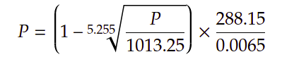

**Pseudocode**:

*Input: pressure of reference sensor Pref, the user device pressure, height of each floor*

*Output: floor number*

*begin*

*alt_ref = 8.37 * Pref;*

*alt_usr = 8.37 * Pusr;*

*floor = Round((alt_ref - alt-usr) - h_floor)*

*return floor*

*end*

### Video of a similar project:

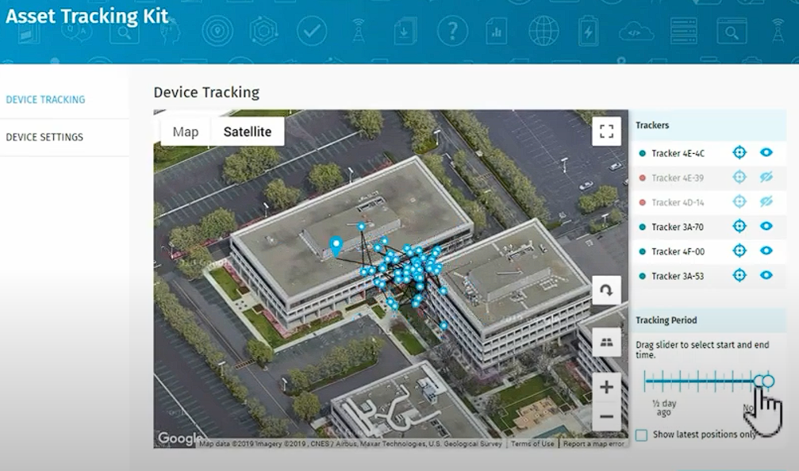

Video Link: [Asset Tracking based system using LoRa technology](https://www.youtube.com/watch?v=o91yVjOgvbM&ab_channel=SemtechCorporation)

# Aim and Statement of Problem

**3.1 Introduction:**

In the process of manual tracking of the assets, it is difficult to identify the exact location of all the assets at the same time. Furthermore, manually maintaining the reports of the usage of assets is also not too easy, it's time consuming, requires lots of paperwork and physical efforts to generate the reports. The major aim of the project is to make it possible for organizations to keep real-time tracking of the assets as well as laborers. The detailed discussion of the problem with respect to the supervisor's perspective is being discussed in this chapter.

**3.2 Problems faced by Supervisor:**

In the process of managing assets and labor, following are the problems faced by supervisor:

**3.2.1 Lack of Assets Maintenance:**

Lack of asset maintenance is one of the oldest issues in many organizations, e.g., work is going on at full swipe and unexpectedly a machine breaks and the work stops. This is the typical case of an unexpected failure. . So, it is important to manage records of each asset as it will make it easier to schedule the maintenance activities without interrupting daily operations.

**3.2.2 Human Error:**

In inventory management, there can be remark and calculation errors. For assets tracking many organizations traditionally used spreadsheets assuming that it will give correct data. So, in real-time assets tracking it minimizes the human errors.

**3.2.3 Time Consumption:**

Performing manual tracking of assets and labor is a difficult and time consuming task.

**3.2.4 Inventory Shortage:**

When there is no asset tracking system in place, there will never be a perfect balance between manufacture rate and inventory stocks. So, without a perfect asset tracking system, you cannot manage inventory shortage, as well as being stressed with wrong information.

# 4. Hardware, Software analysis and requirements

**4.1 Hardware:**

Our project hardware are:

* Raspberry Pi 4
* D1 Mini

**4.1.1 Raspberry Pi 4:**

Raspberry Pi 4 (4 GB memory) will act as a router taking real time log data from the tags attached to assets and labors.

**4.1.2 D1 Mini:**

D1 Mini will be used as a tag attached to an asset or a labor to transmit the real time location over the wifi network to the router.

**4.2 System:**

Our system i.e. CMMS (Computerized Maintenance Management Software) will be a web based application.

**4.3 Software:**

The softwares required are as follows:

* Python
* Angular

**4.3.1 Python:**

Python will be used to develop the backend of our web application as it allows us to perform complex tasks on the backend. It will also be used to configure the routing device (raspberry pi 4).

**4.3.2 Angular:**

Angular framework of typescript will be used as a frontend framework in our application to increase the user experience while performing different operations on CMMS.

**4.4 Requirements:**

**4.4.1 Inputs:**

* As a supervisor, I want all the information of particular assets and labor and their current location to be automatically available in a system where I don't need to search for them.
* As a supervisor, I can add, update, and delete the asset or labor from the system.
* As a supervisor, I want an interface that will be simple and easy to use, nothing should be complex.
* As a supervisor, I want an automatically generated report of all the assets and labors and information regarding their usage.
* As a supervisor, I can check the current status of the asset or labor whether they are available or are currently being used.

**4.4.2 Process:**

* As a system, I want to manage the data repository and make sure to save all the data so that asset allocation will be done in real-time.
* As a system, I need to update the record(data) upon insertion and deletion of assets or laborers.
* As a system, I want to determine the location of the asset and labor with the help of routers.
* As a system, I want to show the availability status of the asset and labor.
* As a system, I want to generate a maintenance report where all details of a specific asset will be available, like how much it is used and where it is used mostly.

**4.4.3 Output:**

* As a supervisor, I want all the information like the lifespan of a particular asset.
* As a supervisor, I want all the reports to manage which assets were most used in which areas so that inventory can be managed easily.
* As a supervisor, I want to see the real time location of the assets and laborers.

**4.4.4 Non-Functional:**

Our project aims to provide a reliable platform (CMMS) for performing the specified functions by ensuring that no failure or error occurs. Continuity of Processing must be covered in the processing stage so that the overall system is recoverable and operable in case of data loss, the system should continue to record the data of assets and labor in case of any failure. At service level, it will be ensured that the data of assets and labor is accurately parsed from the smart tags and presented in the system. It will ensure that a good GUI of the system is developed for checking the data of assets, it must be simple and easy so that users can easily interact with it.

**4.5 Diagrams:**

In the below diagram, Super Admin, CMMS, Asset Tag, and Labor Tag are taken as the main actors. First, the functionalities of Super Admin can be seen in Figure 4.1, Super Admin will initiate the process by controlling CMMS to schedule assets and laborers. Then the CMMS will change the status of the asset as occupied and will assign that asset to the labor simultaneously. After the change of status, both of the tags (asset and labor) will start posting their current location and track movement. Following that, CMMS will record the track movement, will perform monitoring, compute the assets usage/life, and will generate the necessity reports. Finally, Super Admin will be able to view the current location of asset and labor, view software generated reports, and can check the assets usage/life. These were all the use cases discussed in Figure 4.1.

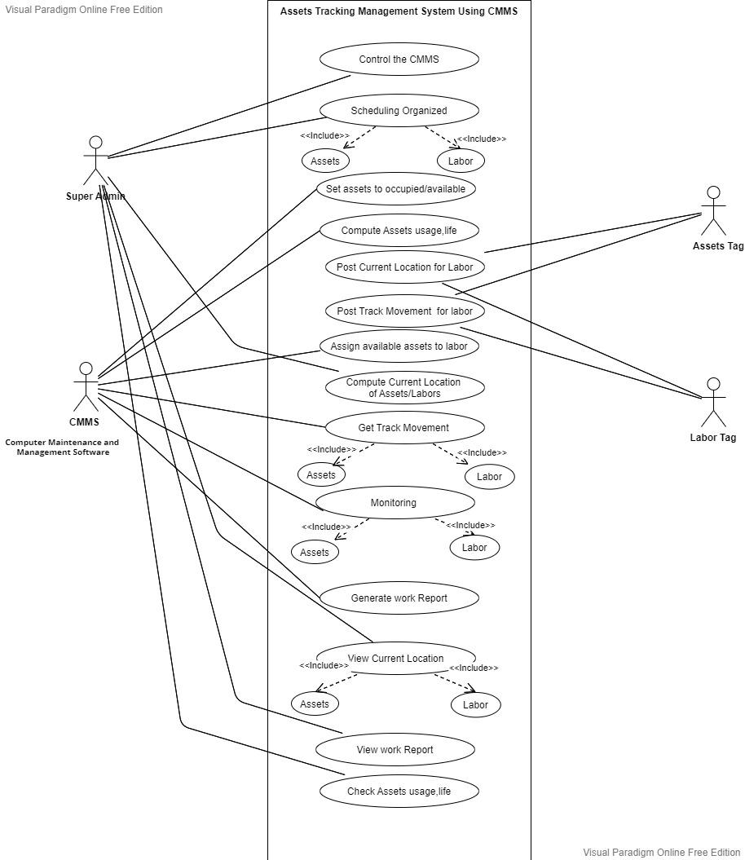**FIGURE 4.1: ACTOR USE CASE**

# 

In Figure 4.2, CMMS will get the data from the tracking devices. The data will then pass through the algorithm to compute the current location and record the track movement. After that, the system will compute the life span of assets and will generate the reports accordingly. In the output stage, the system will perform two actions in the form of GUI.

* System will show the real time location of assets and laborers.
* System will show reports generated during the processing step.

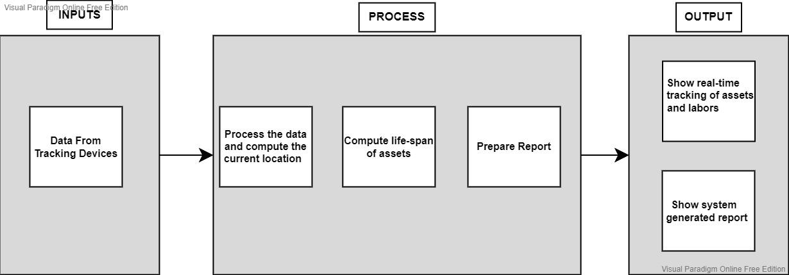

**FIGURE 4.2: SYSTEM DIAGRAM**

Figure 4.3 provides a clear view of the activities performed by the system. First of all the admin will access the CMMS by providing validated credentials. If the credentials are valid the CMMS will allow the access to the admin otherwise it will display the error message and will move the admin back to the login page. After entering the CMMS, the admin can view the tracking location of asset and labor and can request the CMMS to show the reports. Upon a report request by the admin, the CMMS will provide the newly generated reports. If the admin requests for the tracking location of asset and labor, the CMMS will display the real time tracking of asset and labor. The data shown to the admin by CMMS would be transmitted by the tags attached with the asset and labor to the routers and then the router will perform the responsibility of forwarding the data to the CMMS, which will then compute the real time location and will perform the display activity to the admin.

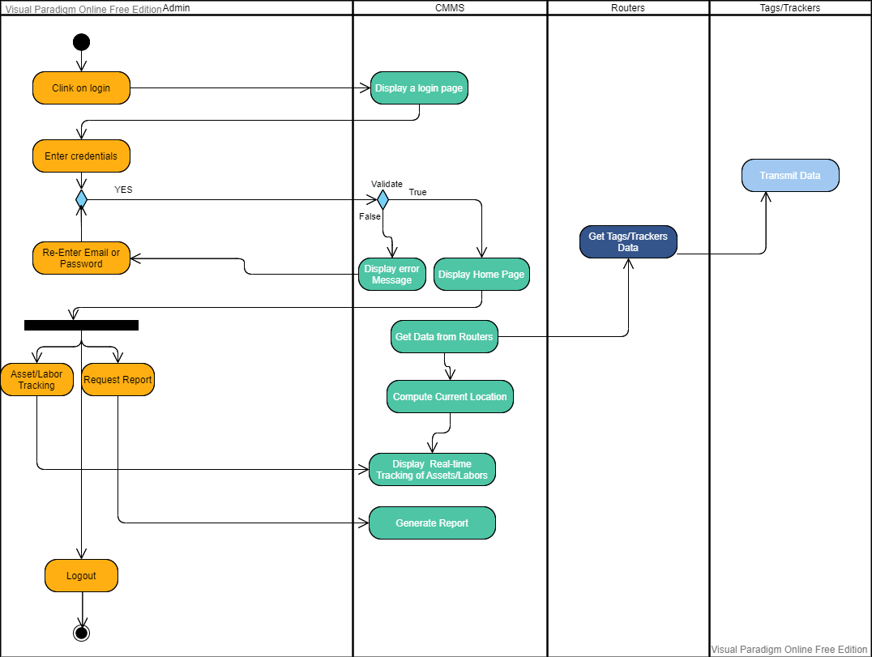

**FIGURE 4.3: ACTIVITY DIAGRAM**

Figure 4.4 can be briefly explained through the following:

* Actors: Super Admin, CMMS, Router, Smart Tag.
* Processing: System Software.
* All relations depend upon our implementation of asset and labor tracking through CMMS.

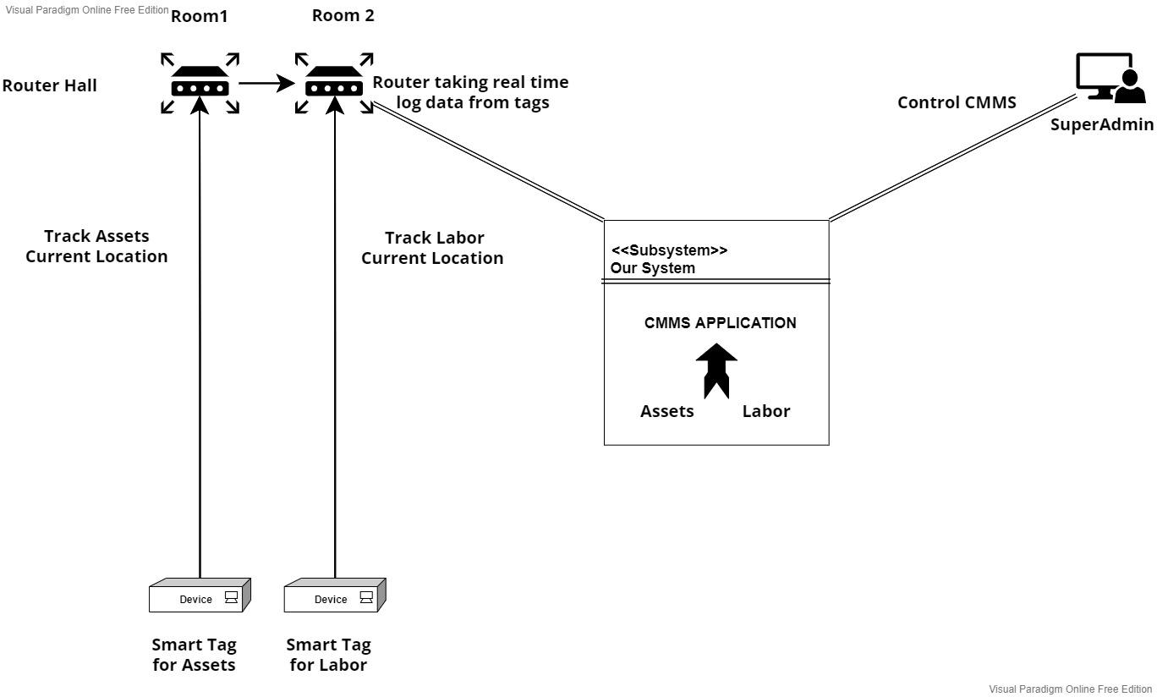

**FIGURE 4.4: OPERATIONAL DIAGRAM**

# Software design and modeling

In this chapter project architecture is presented (explain which architecture is used), overall design diagrams (complete object diagram, complete class diagram, database diagram, etc.) to be shown. (as such diagrams are usually huge in nature, it is appropriate to print in on A3 or bigger sheets, and then fold it to A4 size).use few behavioral diagrams (sequence diagram, timing diagram, activity diagram, state transition diagram, or composite diagram) only for core technical functionality of the project against use cases. Also show high fidelity prototypes against each use case.

# Algorithm analysis and complexity

In this chapter you have to mention algorithms that are used in project. Its purpose and significance, along with its pseudocode. Compare your selected algorithm with such other algorithms. For each algorithm show its best, average, and worst values in context of time and space complexity. Show primary references of all mentioned algorithms.

# Implementation

Give code details (not a complete listing, but description of key parts). Discuss the most important/interesting aspects. It probably won’t be possible to discuss everything- give a rationale for what you do. Code shall not be more than 3-5 pages. Use appropriate code writing standards, draw operational diagram, component diagram and deployment diagram. Show only two to three technical interfaces that represents the core project functionality with explanation (You may use POC interfaces). Draw state transition diagram of project interface (input, output, and processes).

# Testing

This chapter contains Whitebox of most logical code, and black box testing of that interfaces that represents core functionality of the project. Some of the system level structural and functional testing must be shown with the help of tools. You have to show test plan – how the program/system was verified. Put the actual test results in the annexure.

This chapter also covers results of different types of experiments/simulations that were carried out with the code written. Why were certain experiments in the simulation used and how did they affect the results? If there are very many graphs and tables associated with this Chapter they may be placed in annexure.

# Discussion (optional)

This Chapter should fully and logically discuss the progression of the project including the methods used and the results of experimentation, or the design; in such a way that examiner can evaluate the worth of the project. The discussion should be backed by detailed reference to material in the testing chapter of the report.

# Conclusions

This Chapter should be a concise statement of the conclusions which may be drawn from the work attempted. The reader needs to be convinced that the design will work. If

Uncertainties remain, they should be pointed out, and alternatives, such as modifying performance specifications, should be spelled out to deal with foreseeable outcome.

# Future work

This Chapter may be used to propose further work which may be carried out on the project in subsequent study projects. Suggestions of this type should be limited to proposals which involve significant amounts of work such as major modifications of equipment or development of student practical experiments/enhancement. If any component is developed, how it can be utilized with proper documentation. Any suggestion is to be given in sufficient detail to provide adequate information for a future student to be able to fully appraise the proposal. which other similar project can be developed by using same concept with different domain/technology.

# Achievements

In this chapter you have to summarize your participations in different competitions, conferences, incubation activities, and exhibitions. It is desired to express your experience about such activities. Also mention what you achieved in such activities e.g experience, acknowledgement, certificates, souvenirs , and rewards

# Appendices

These shall be used to give detailed results that shall be summarized in main text. The normal practice is “Annex A, B, C…” and, when required, “Appendix (to annex) 1, 2, 3…..” They should identify on every page by running header. Following items should be included in appendices

In **acknowledgement chapter**, you may include official letters from organizations.

In **introduction chapter** 2-3 pages about organization for which you are developing the project

In **background and literature review chapter**, research paper that is basis of your project, details of similar projects, any UML diagrams from other sources that has strong relationship with your project

In **hardware, software analysis and requirement,** you may add hardware pacification, use case narrations, or detailed requirement specification document.

In **software design and modeling chapter**, you may add detailed design documents other than most significant.

In **software algorithm and complexity**, you may attach actual algorithm or its research paper.

In **achievement chapter**, you have to mention correspondence (letters, emails etc.), copy of certificate, pictures of participation specially at time of award ceremony.

You may add any detail that is summarized in any chapters but need more focus and clarity for reader.

# General Guidelines

- Begin each chapter on new page.

- Each chapter should have small introduction at beginning of chapter. Introduction must link to previous chapter. It is a one or more then one paragraph but not more than one page that introduces the reader to the subject. The introduction presents basic background material, the history of the problem and contains the key sentence outlining the subjects to be discussed.

The total report length should under no circumstances exceed **120 pages**; most projects somewhat shorter. There is no value in trying to artificially lengthen your project by ‘padding’ it. Each project is unique and has its own natural length, and you will probably know when you have said everything that you need to be said.

## Typing and size of paper

I. The report is to be typewritten on one side of the paper on international size A4 paper (297mmX210mm). This paper must be good quality bond (70-90 gsm).

ii. Reports length should be 80-120 pages.

iii. Use Times New Roman, size 12 font throughout the reports.

Use 1.5 or double spacing.

## Page number and Chapter number

- Use lower case Roman numerals for preliminary pages

I. Title page (not numbered on page)

ii. Abstract

Table of Contents

The text of the report begins with Arabic number 1. Number all pages. Page numbers can be inserted either at the bottom/top right or the bottom/top center.

All appendices should number as A-1, A-2, etc. for pages under appendix A, and B-1, B-2, etc. for pages under appendix B (See Table of Contents.).

A hierarchical numbering scheme for chapter numbering shall be used. For instance, use 1 for chapter one, 2 for chapter 2, 1.1 for the subsection 1 of chapter 1, etc. (See the Table of Contents).

## Margin boundaries

I. 1 -inch left margin.

ii. 0.5-inch margin on the other three sides.

## Diagrams and figures

Figures and table should be inserted in the text in one of the three places

A full page figure or illustration must be inserted on the left hand side facing the typescript which described it.

Small figure should be incorporated in the text with the legend appearing below (not recommended).

Each graph, figure, etc., should have a figure number and title typed below it. The type style should be same as the text. Figures should be numbered by chapters (Fig. 1.1, Fig 1.2, Fig. 2.1, etc). explain each figure by referring its number (e.g. in Fig 1.1), don’t assume any figure is self-explanatory. Whichever numbering system you use, make sure that you follow the same system for tables and equations, also explain then as figures.

Line drawings, graphs, and monograms should be in bold clear lines. Where graphs, diagrams and figures cannot be mounted vertically on the page these are to be mounted and labeled in such a way that they can be read from the right hand side(900 on the page) of the page .

All the axes of graphs are to be labeled with the parameter and its units. Information on illustrations and graphs such as labels, scales etc. must be typewritten.

## Photocopying

All the figures, etc. must be reproduced by an electronic or electrostatic or photographic method which is known not to fade.

## Fixing of photograph

Full page photographs should be bound into the report. Small photographs must be firmly fixed to the paper. An alternative is to use color photocopying or digital processing.

## Tables

Each table should be numbered consecutively (Table 1, Table 2) or by chapter (Table 1.1, Table 1.2, Table 2.1).Table number should be centre above the top of the table and be followed on the next line by a brief descriptive caption, preferably in cap. The type should be the same as the text. Refer to each table in text by number “In Table 1, one can clearly see………”The same rules for location of figures apply to tables.

TABLE 1. MEASURED RESISTOR VALUES AND THE METER ERROR

|  |  |  |
| --- | --- | --- |
| Nominal Value Marked | Measured Value | Error (%) |
|  |  |  |
|  |  |  |

## Equations

Centre each equation on separate line. Number equations consecutively in parentheses at the right margin. Equation may be referenced by number in the text, using parentheses around the number.

Y (t) = ∫sin (x) dx (1)

## Units

The S.I. system of units is to be used throughout. Where difficulties are introduced by quotation of imperial units from reference source, these should be accompanied by the appropriate conversion to S.I. units in parentheses.

## References

At the end of your work, list full details of all of the sources which you have cited in your text in a section headed *References*, in numeric order. References listed must follow IEEE formatting guidelines (see reference examples overleaf). Your reference list should allow anyone reading your work to identify and find the material to which you have referred.

In IEEE style your reference list should be formatted in the following way:

* Align references left
* Single-space each entry, double-space between every new entry
* Place number of entry at left margin, enclose in square brackets [ ] Indent text of entries

### Citations/references with multiple authors

If you choose to mention the author(s) of a source whilst citing it in the text of your work, if there are three or more you can abbreviate them using ‘et al.’ e.g. During their research, Fan, et al. [4] discuss lasers in detail. However, in general you do not need to mention the authors by name, just use the numeric citation in square brackets. In your full reference list at the end however, you always give the authors’ names. In the reference list you can only abbreviate these using ‘et al.’ if there are six or more authors.

### Reference examples

There are standard reference formats for most types of document. Below are examples of the most common types of document you might want to reference. Each of the following gives a suggested standard format for the reference followed by examples for the different document types.

### Book

[Ref number] Author’s initials. Author’s Surname, *Book Title*, edition (if not first). Place of publication: Publisher, Year.

[1] I.A. Glover and P.M. Grant, *Digital Communications*, 3rd ed. Harlow: Prentice Hall, 2009.

### Book chapter

[Ref number] Author’s initials. Author’s Surname, “Title of chapter in book,” in *Book Title,* edition (if not first), Editor’s initials. Editor’s Surname, Ed. Place of publication: Publisher, Year, page numbers.

[2] C. W. Li and G. J. Wang, "MEMS manufacturing techniques for tissue scaffolding devices," in *Mems for Biomedical Applications*, S. Bhansali and A. Vasudev, Eds. Cambridge: Woodhead, 2012, pp. 192-217.

### Electronic Book

[Ref number] Author’s initials. Author’s Surname. (Year, Month Day). *Book Title* (edition) [Type of medium]. Available: URL

[3] W. Zeng, H. Yu, C. Lin. (2013, Dec 19). *Multimedia Security Technologies for Digital Rights Management* [Online]. Available: http://goo.gl/xQ6doi

Note: If the e-book is a direct equivalent of a print book e.g. in PDF format, you can reference it as a normal print book.

### Journal article

[Ref number] Author’s initials. Author’s Surname, “Title of article,” *Title of journal abbreviated in Italics,* vol. number, issue number*,* page numbers, Abbreviated Month Year.

[4] F. Yan, Y. Gu, Y. Wang, C. M. Wang, X. Y. Hu, H. X. Peng, et al., "Study on the interaction mechanism between laser and rock during perforation," *Optics and Laser Technology,* vol. 54, pp. 303-308, Dec 2013.

Note: the above example article is from a journal which does not use issue numbers, so they are not included in the reference.

### E-Journal article

PDF versions of journal articles are direct copies of the print edition, so you can cite them as print journals.

[Ref number] Author’s initials. Author’s Surname. (Year, Month). “Title of article.” *Journal Title* [type of medium]. volume number, issue number, page numbers if given. Available: URL

[5] M. Semilof. (1996, July). “Driving commerce to the web-corporate intranets and the internet: lines blur”. *Communication Week* [Online]. vol. 6, issue 19. Available: http://www.techweb.com/se/directlinkcgi?CWK19960715S0005

**When you are compiling your reference list you may abbreviate journal titles:**

For a list of IEEE abbreviations go to:

<https://www.ieee.org/documents/trans_journal_names.pdf>

For non IEEE journal abbreviations go to:<http://www.bath.ac.uk/library/help/infoguides/abbreviations.html>

For further information on the common abbreviations of words used in references for the IEEE style go to:

<http://www.ieee.org/documents/style_manual.pdf>

### Conference papers

[Ref number] Author’s initials. Author’s Surname, “Title of paper,” in *Name of Conference,* Location, Year, pp. xxx.

[6] S. Adachi, T. Horio, T. Suzuki. "Intense vacuum-ultraviolet single-order harmonic pulse by a deep-ultraviolet driving laser," in *Conf.* *Lasers and Electro-Optics*, San Jose, CA, 2012, pp.2118-2120.

Standard abbreviations may be applied to the title of the conference. For a table of abbreviations go to: <http://www.ieee.org/documents/ieeecitationref.pdf>

### Reports

The general form for citing technical reports is to place the name and location of the company or institution after the author and title and to give the report number and date at the end of the reference. If the report has a volume number add it after the year.

[Ref number] Author’s initials. Author’s Surname, “Title of report,” Abbreviated Name of Company., City of Company., State, Report number, year.

[7] P. Diament and W. L. Luptakin, “V-line surface-wave radiation and scanning,” Dept. Elect. Eng., Colombia Univ., New York, Sci Rep. 85, 1991.

### Patents

[Ref number] Author’s initials. Author’s Surname, “Title of patent,” Country where patent is registered. Patent number, Abbrev of Month Day Year.

[8] J. P. Wilkinson, “Nonlinear resonant circuit devices,” U.S. Patent 3 624 125, July 16 1990.

Note: Use “issued date” if several dates are given.

### Standards

[Reference number] *Title of Standard*, Standard number, date.

[9] *Shunt power capacitors*, IEEE standard18-2012, 2013.

### Theses/Dissertations

[Ref number] Author’s initials. Author’s Surname, “Title of thesis,” Designation type, Abbrev. Dept., Abbrev. Univ., City of Univ., State, Year.

[10] J. O. Williams, “Narrow-band analyser,” Ph.D. dissertation, Dept. Elect. Eng., Harvard Univ., Cambridge, MA, 1993.

### Datasheets

[Ref number] Author’s initials. Authors Surname, “Title of Datasheet,” Part datasheet, Publication date [Latest revision date].

[11] Texas Instruments, “High speed CMOS logic analog multiplexers/demultiplexers,” 74HC4051 datasheet, Nov. 1997 [Revised Sept. 2002].

### Online Documents

If you are using documents such as a report, conference paper, standard, patent or thesis online and it also exists as an identical print equivalent i.e. with the same format and pagination, it can be usually be referenced as the print version.

If it is e-only, you can make the standard reference template an electronic version by adding the material type in square brackets

e.g. [Online] after the document title. If there is no specific document title you can place this after the document number (e.g. patent number).

At the end of the reference add: Available: URL. See below for an example of an online patent:

[12] M.R. Brooks, “Musical toothbrush with adjustable neck and mirror,” U.S Patent *326189* [Online], May 19 1992. Available: http://goo.gl/VU1WEk

### Websites

Note: Include as much of the key information as you can find for a given website. If a web page has no personal author, you can use a corporate author. Failing that, you can use either Anon. (for anonymous) or it is permissible to use the title of the site.

[Ref number] Author’s initials. Authors Surname. (Year, Month. Day). *Title of web page* [Online]. Available: URL

1. BBC News. (2013, Nov. 11). *Microwave signals turned into electrical power* [Online]. Available: http://www.bbc.co.uk/news/technology-24897584

1. M. Holland. (2002). *Guide to citing internet sources* [Online]. Available: http://www.bournemouth.ac.uk/library/using/guide_to_citing_internet_sourc.html